**Lab 9: BJT Amplifier Design**

**Faizan Bangash**

**Ecen 325-504**

**November 7, 2018**

**Calculations**

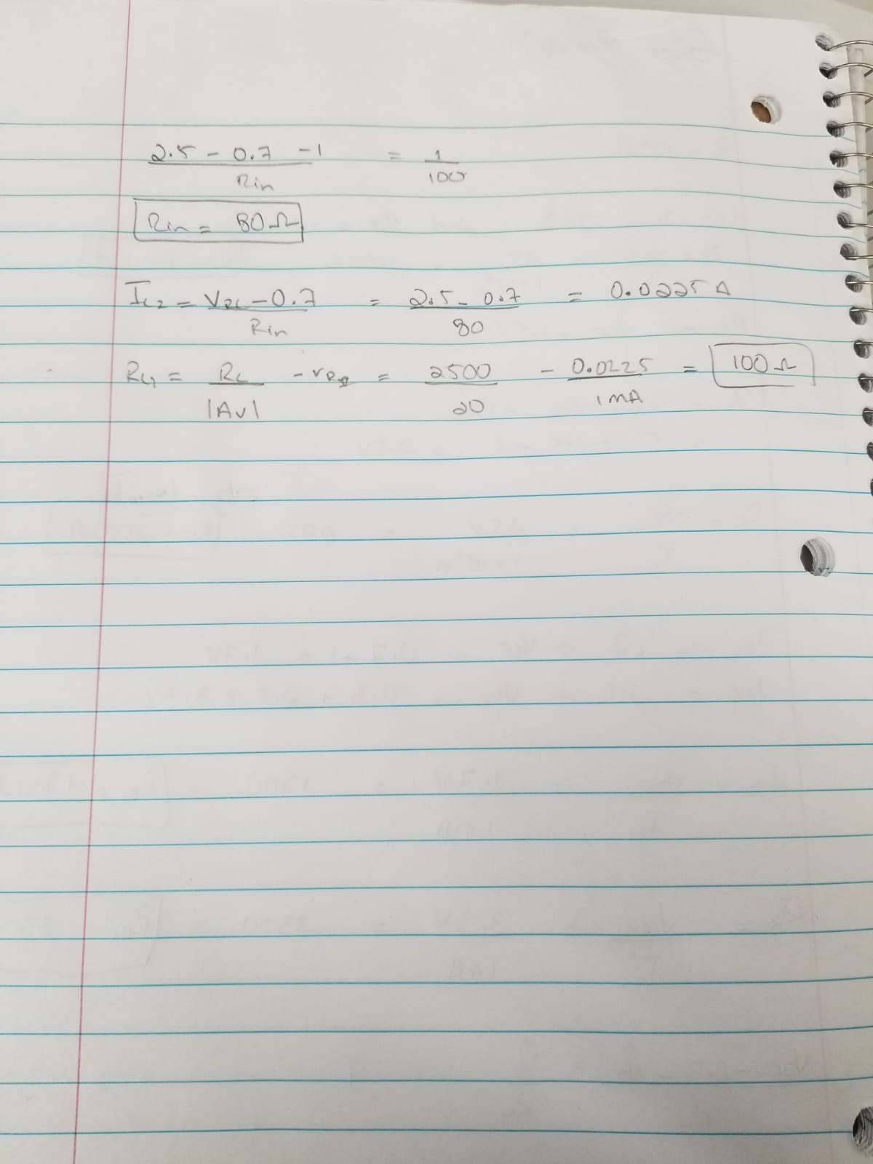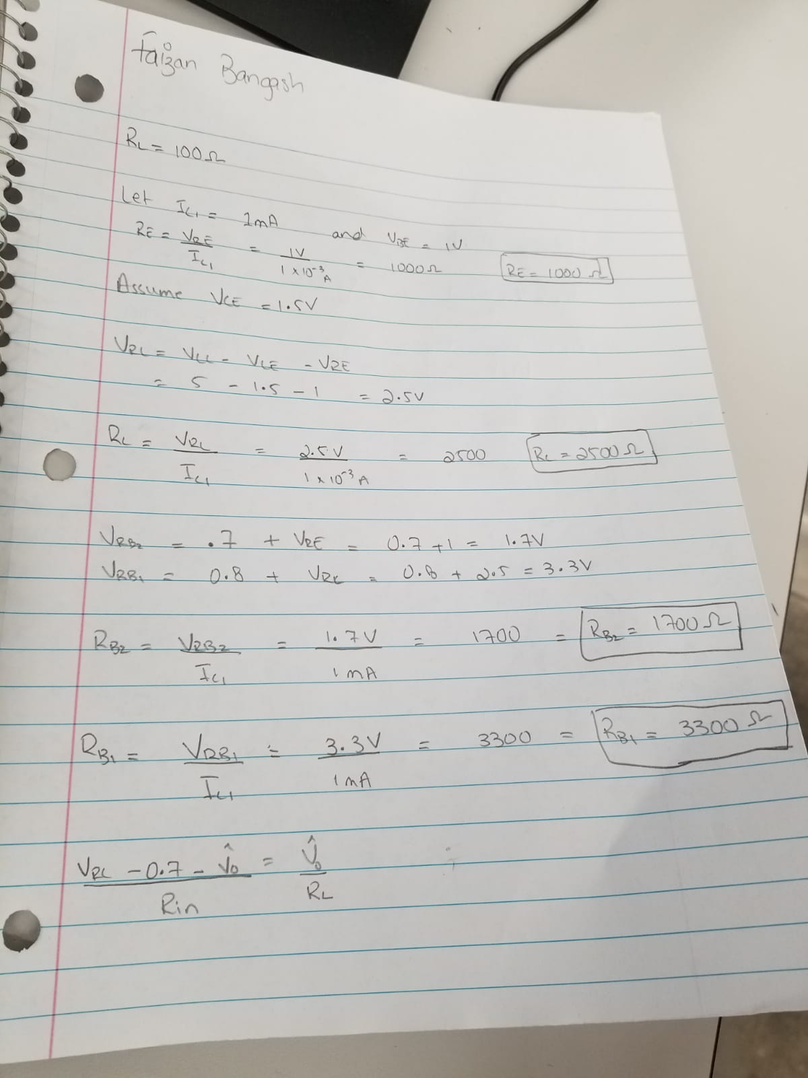

**Simulations**

Two-stage BJT amplifier

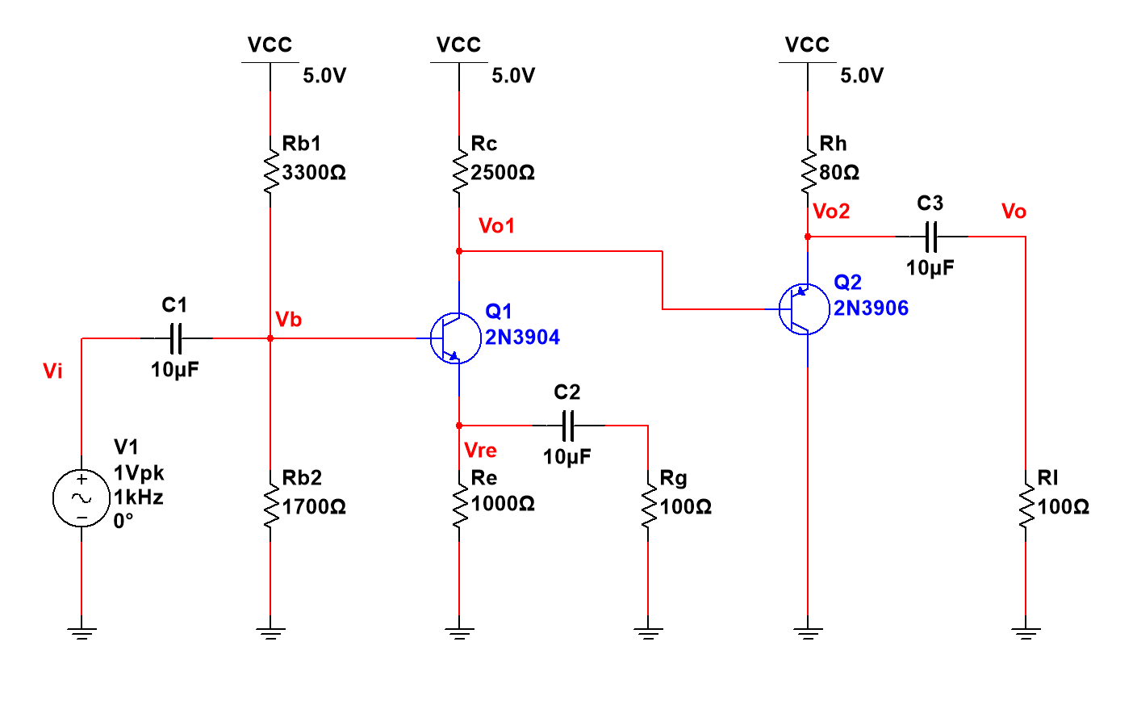

DC operating point

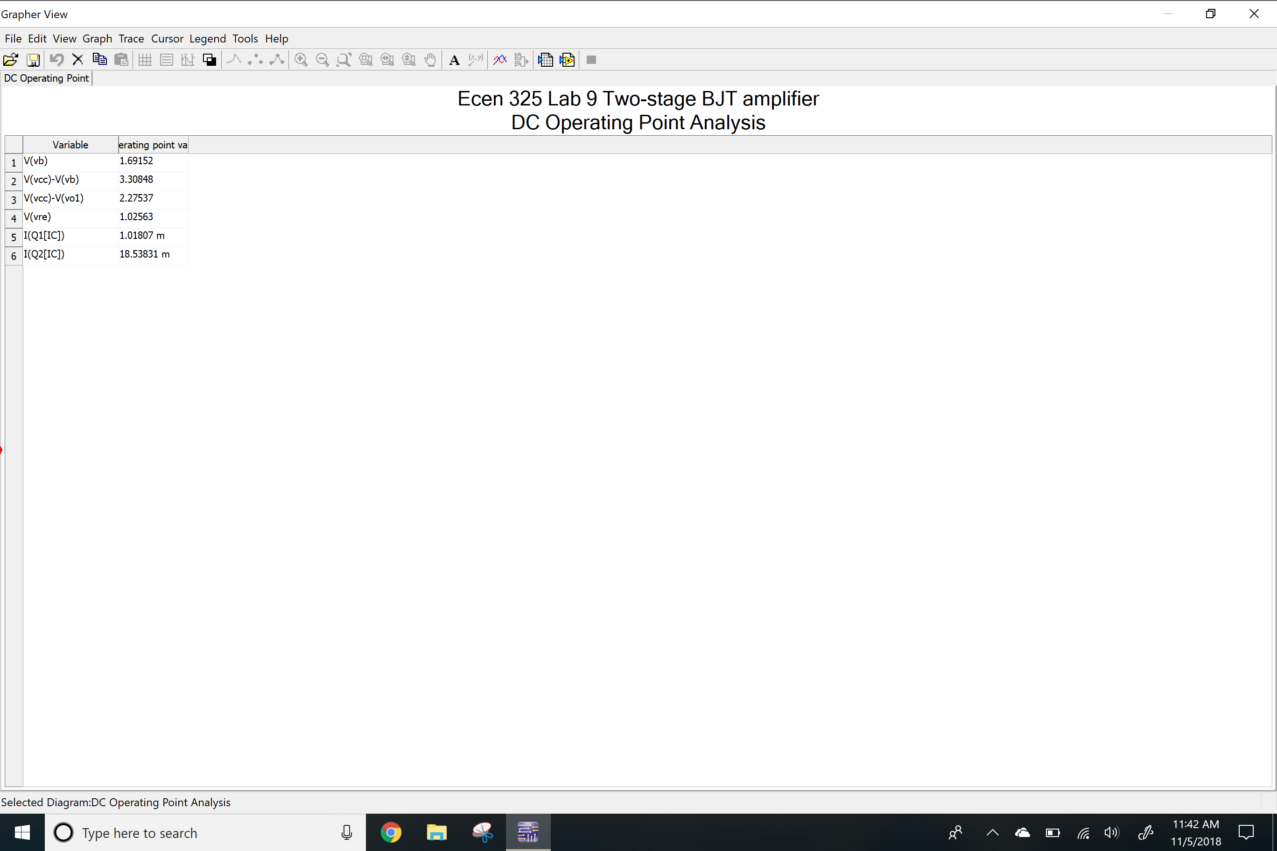

AC Simulation: Av

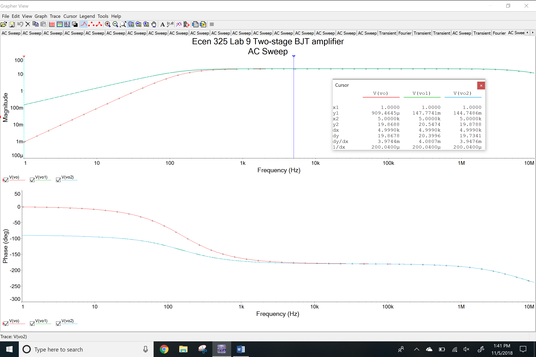

AC simulation: Ri

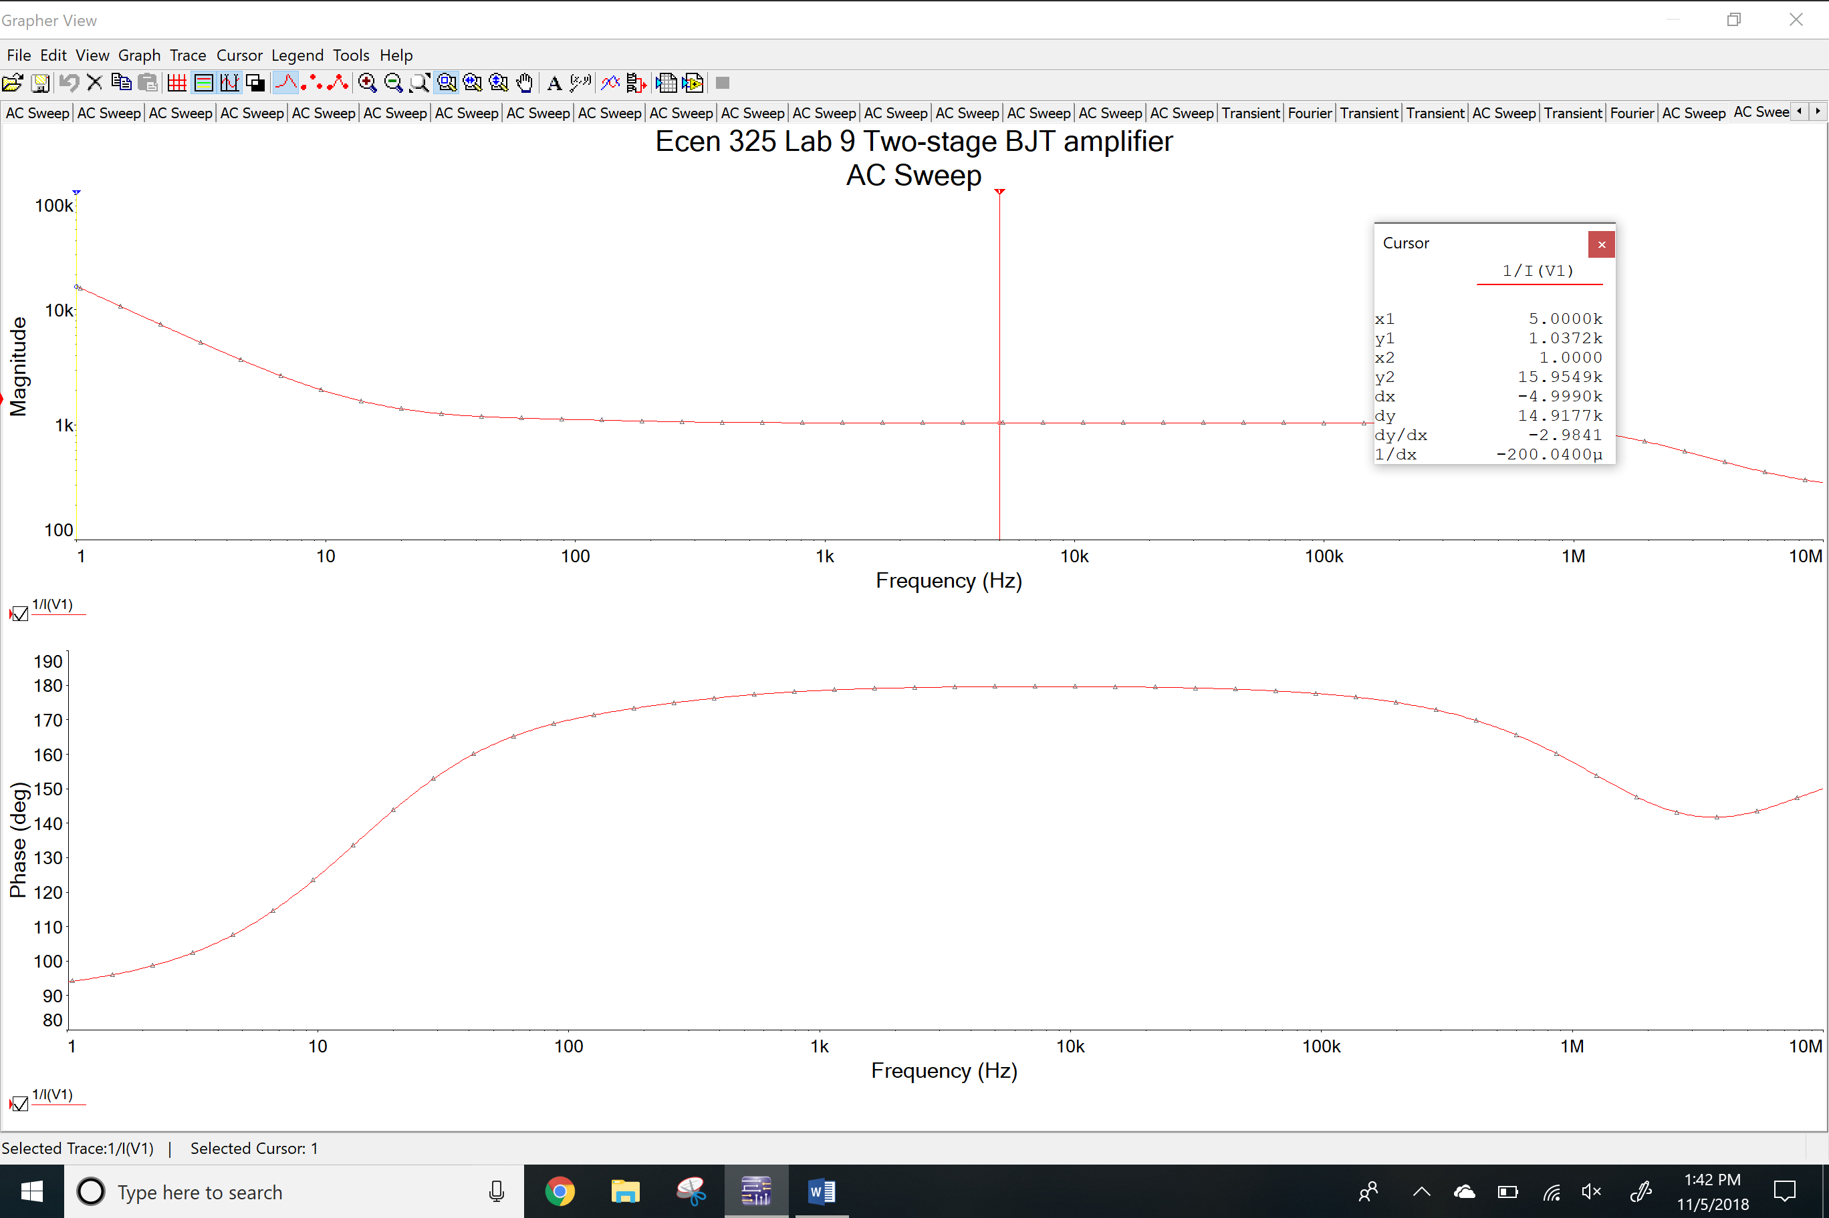

Transient simulation

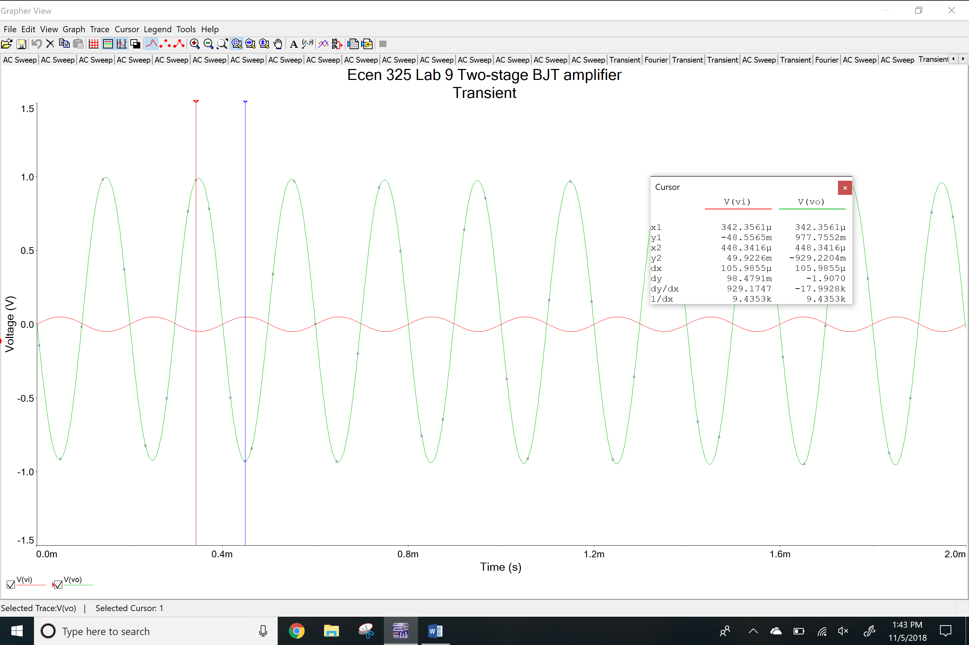

THD

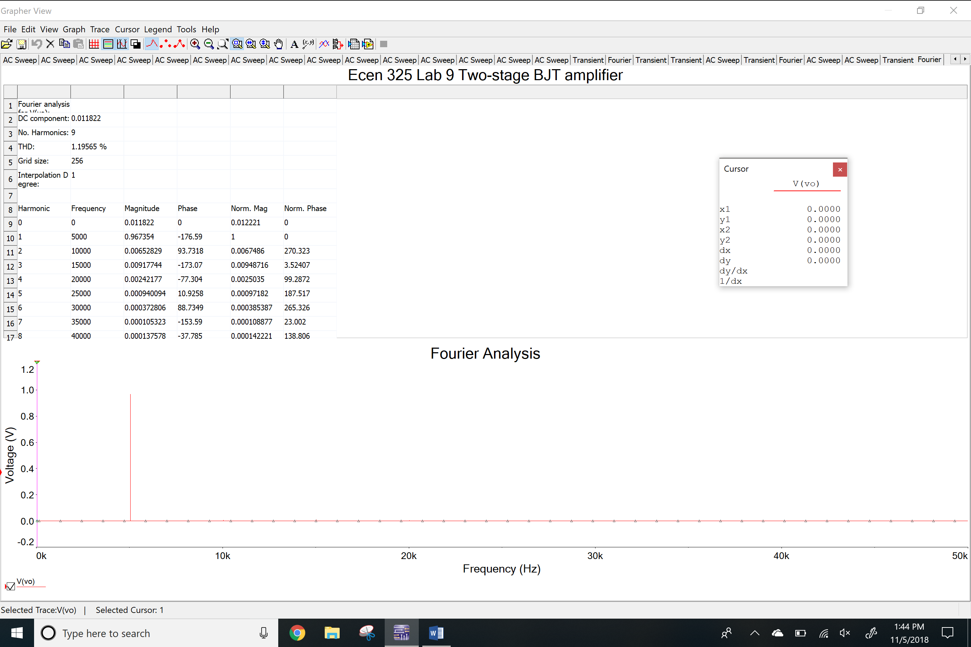

**Measurements**

DC voltages

Vrb1

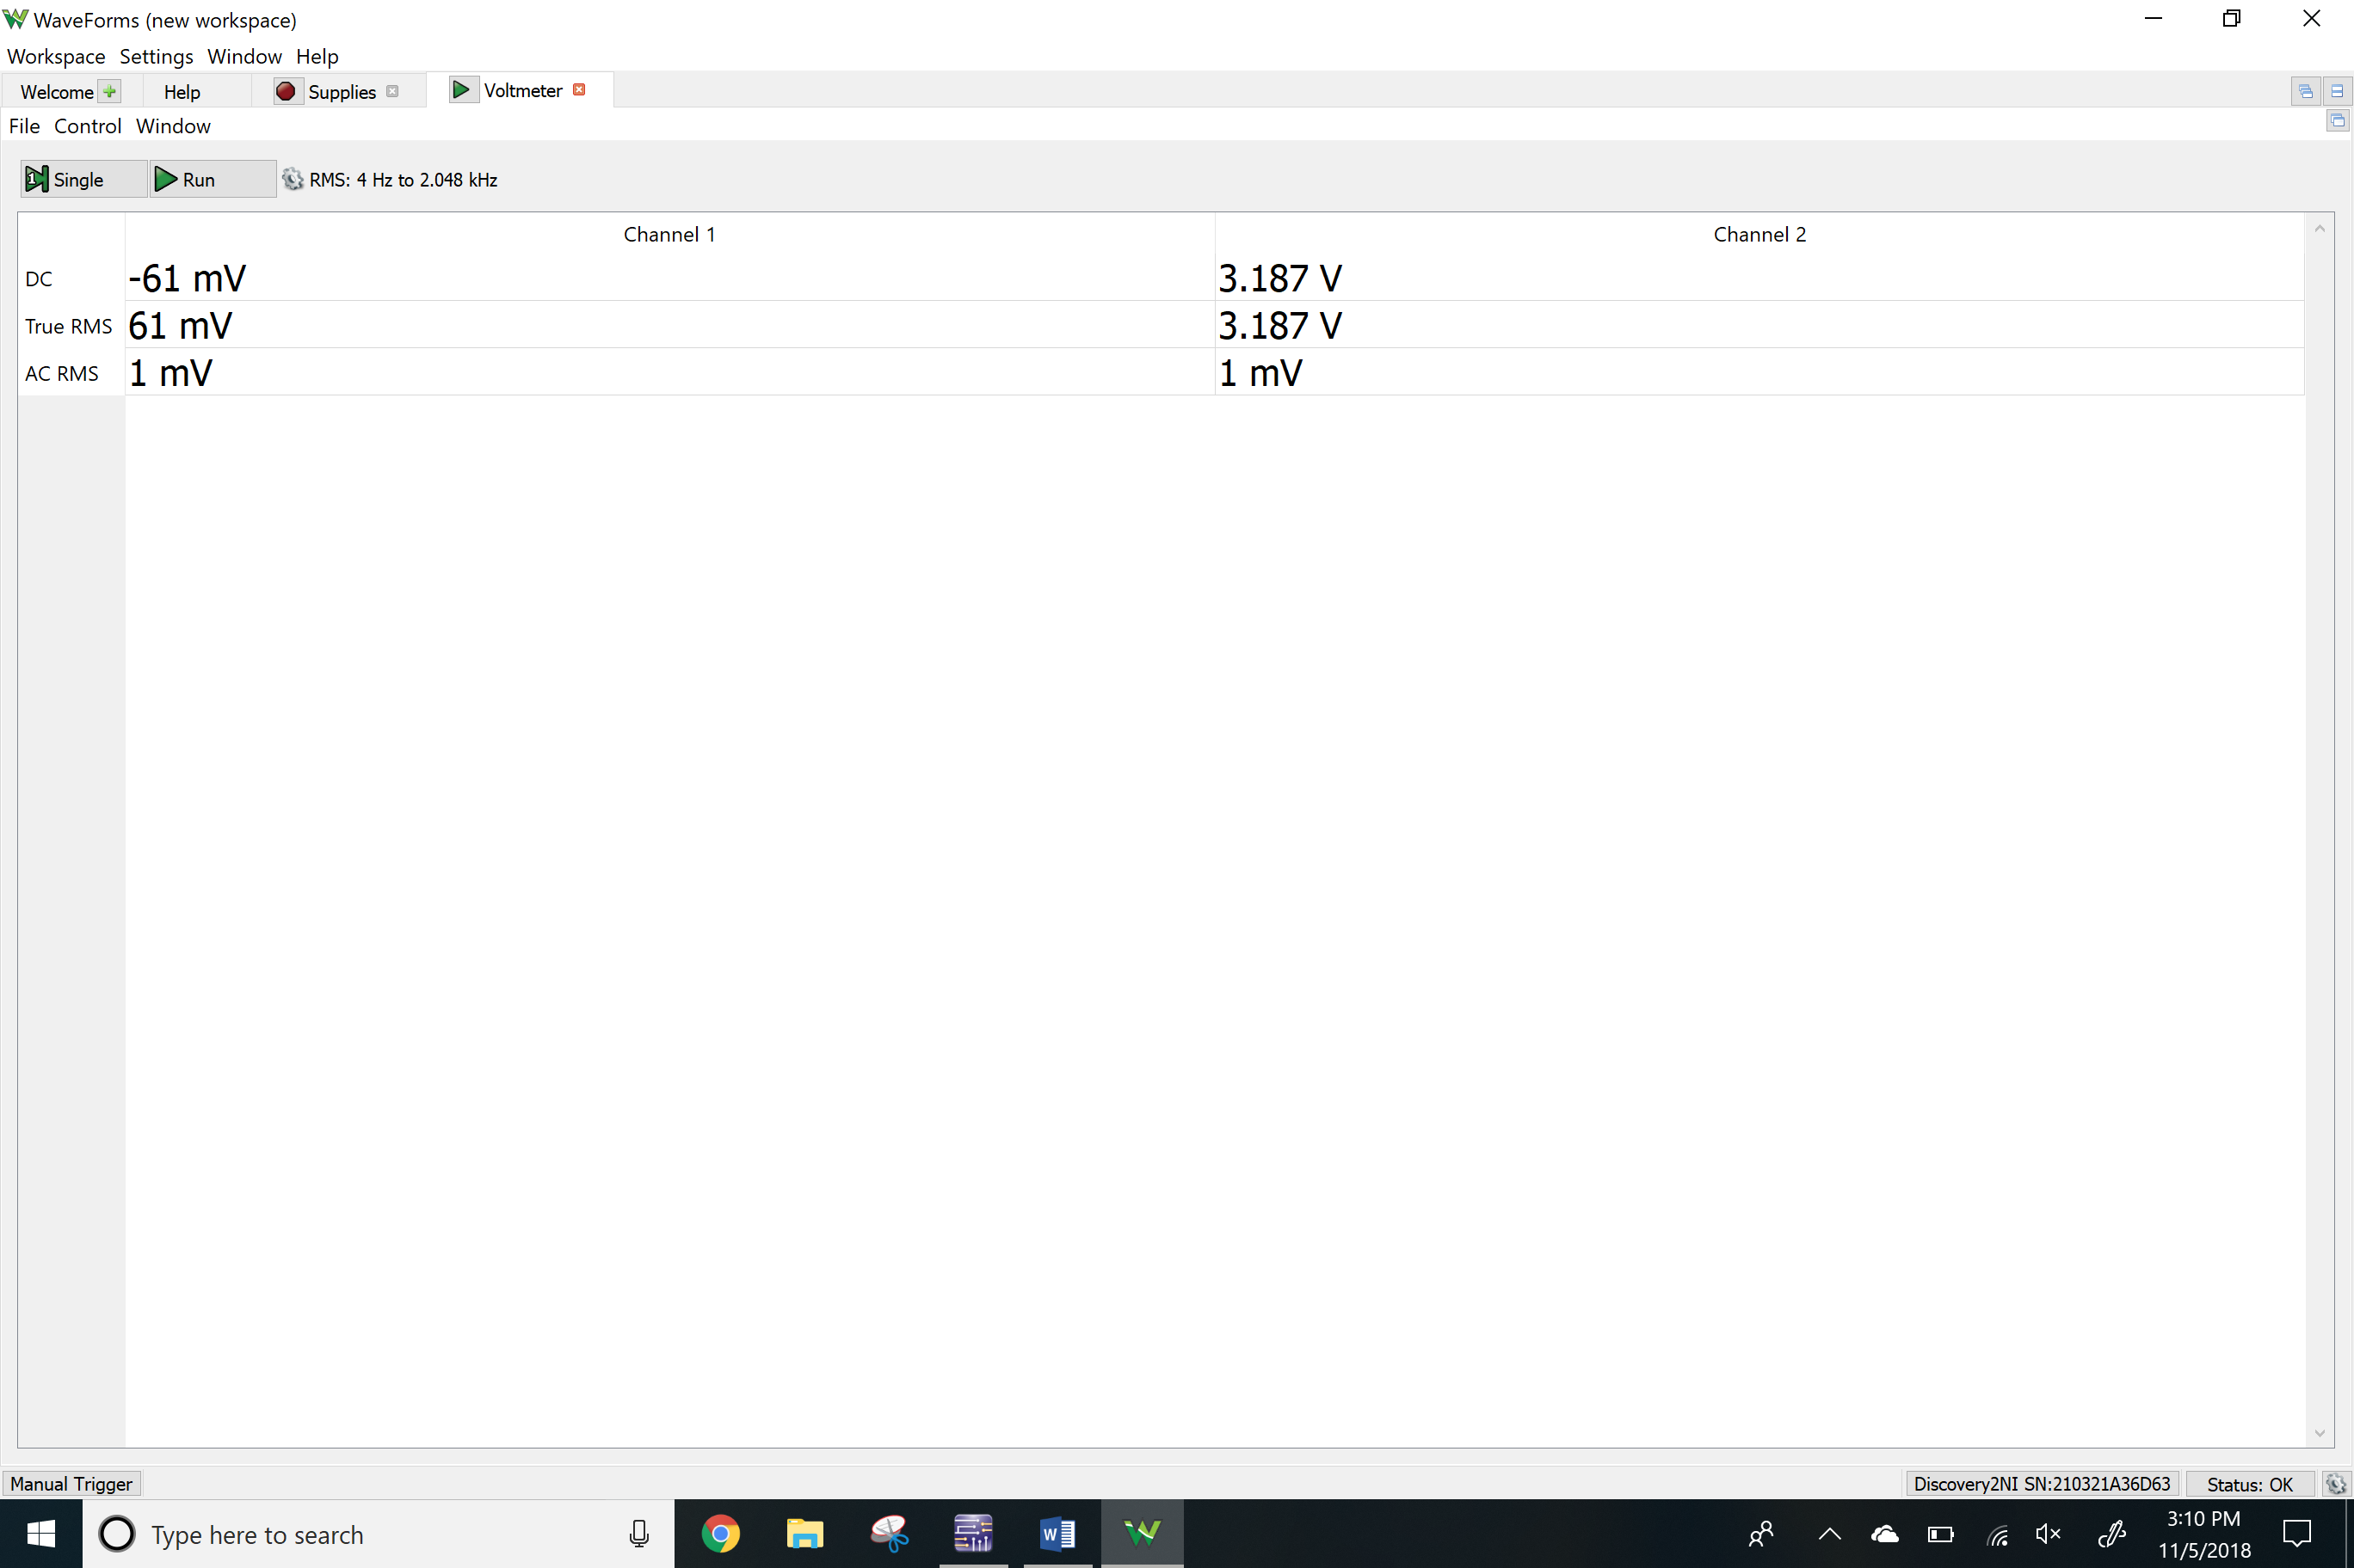

Vrb2

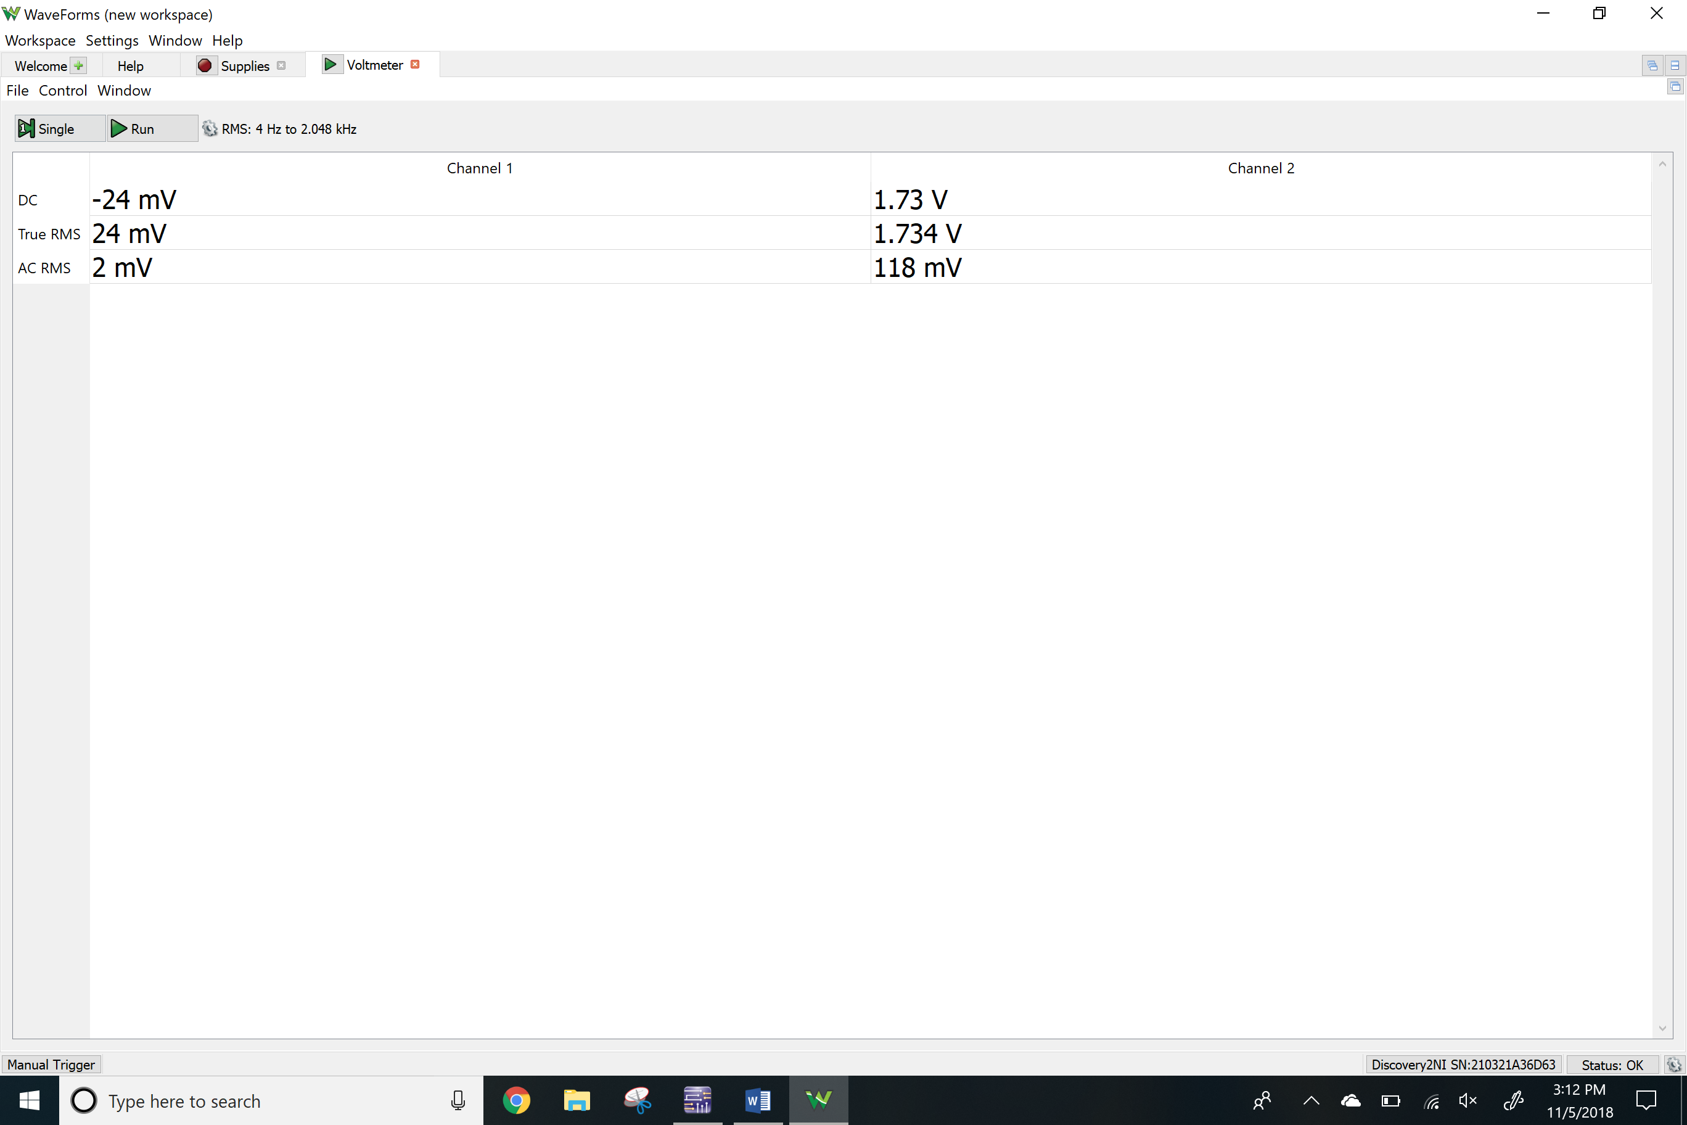

Vrc

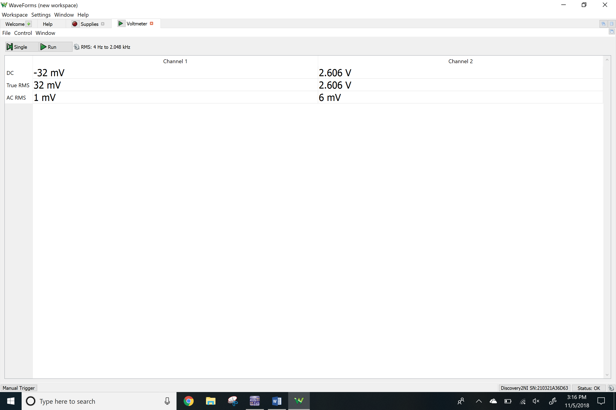

Vre

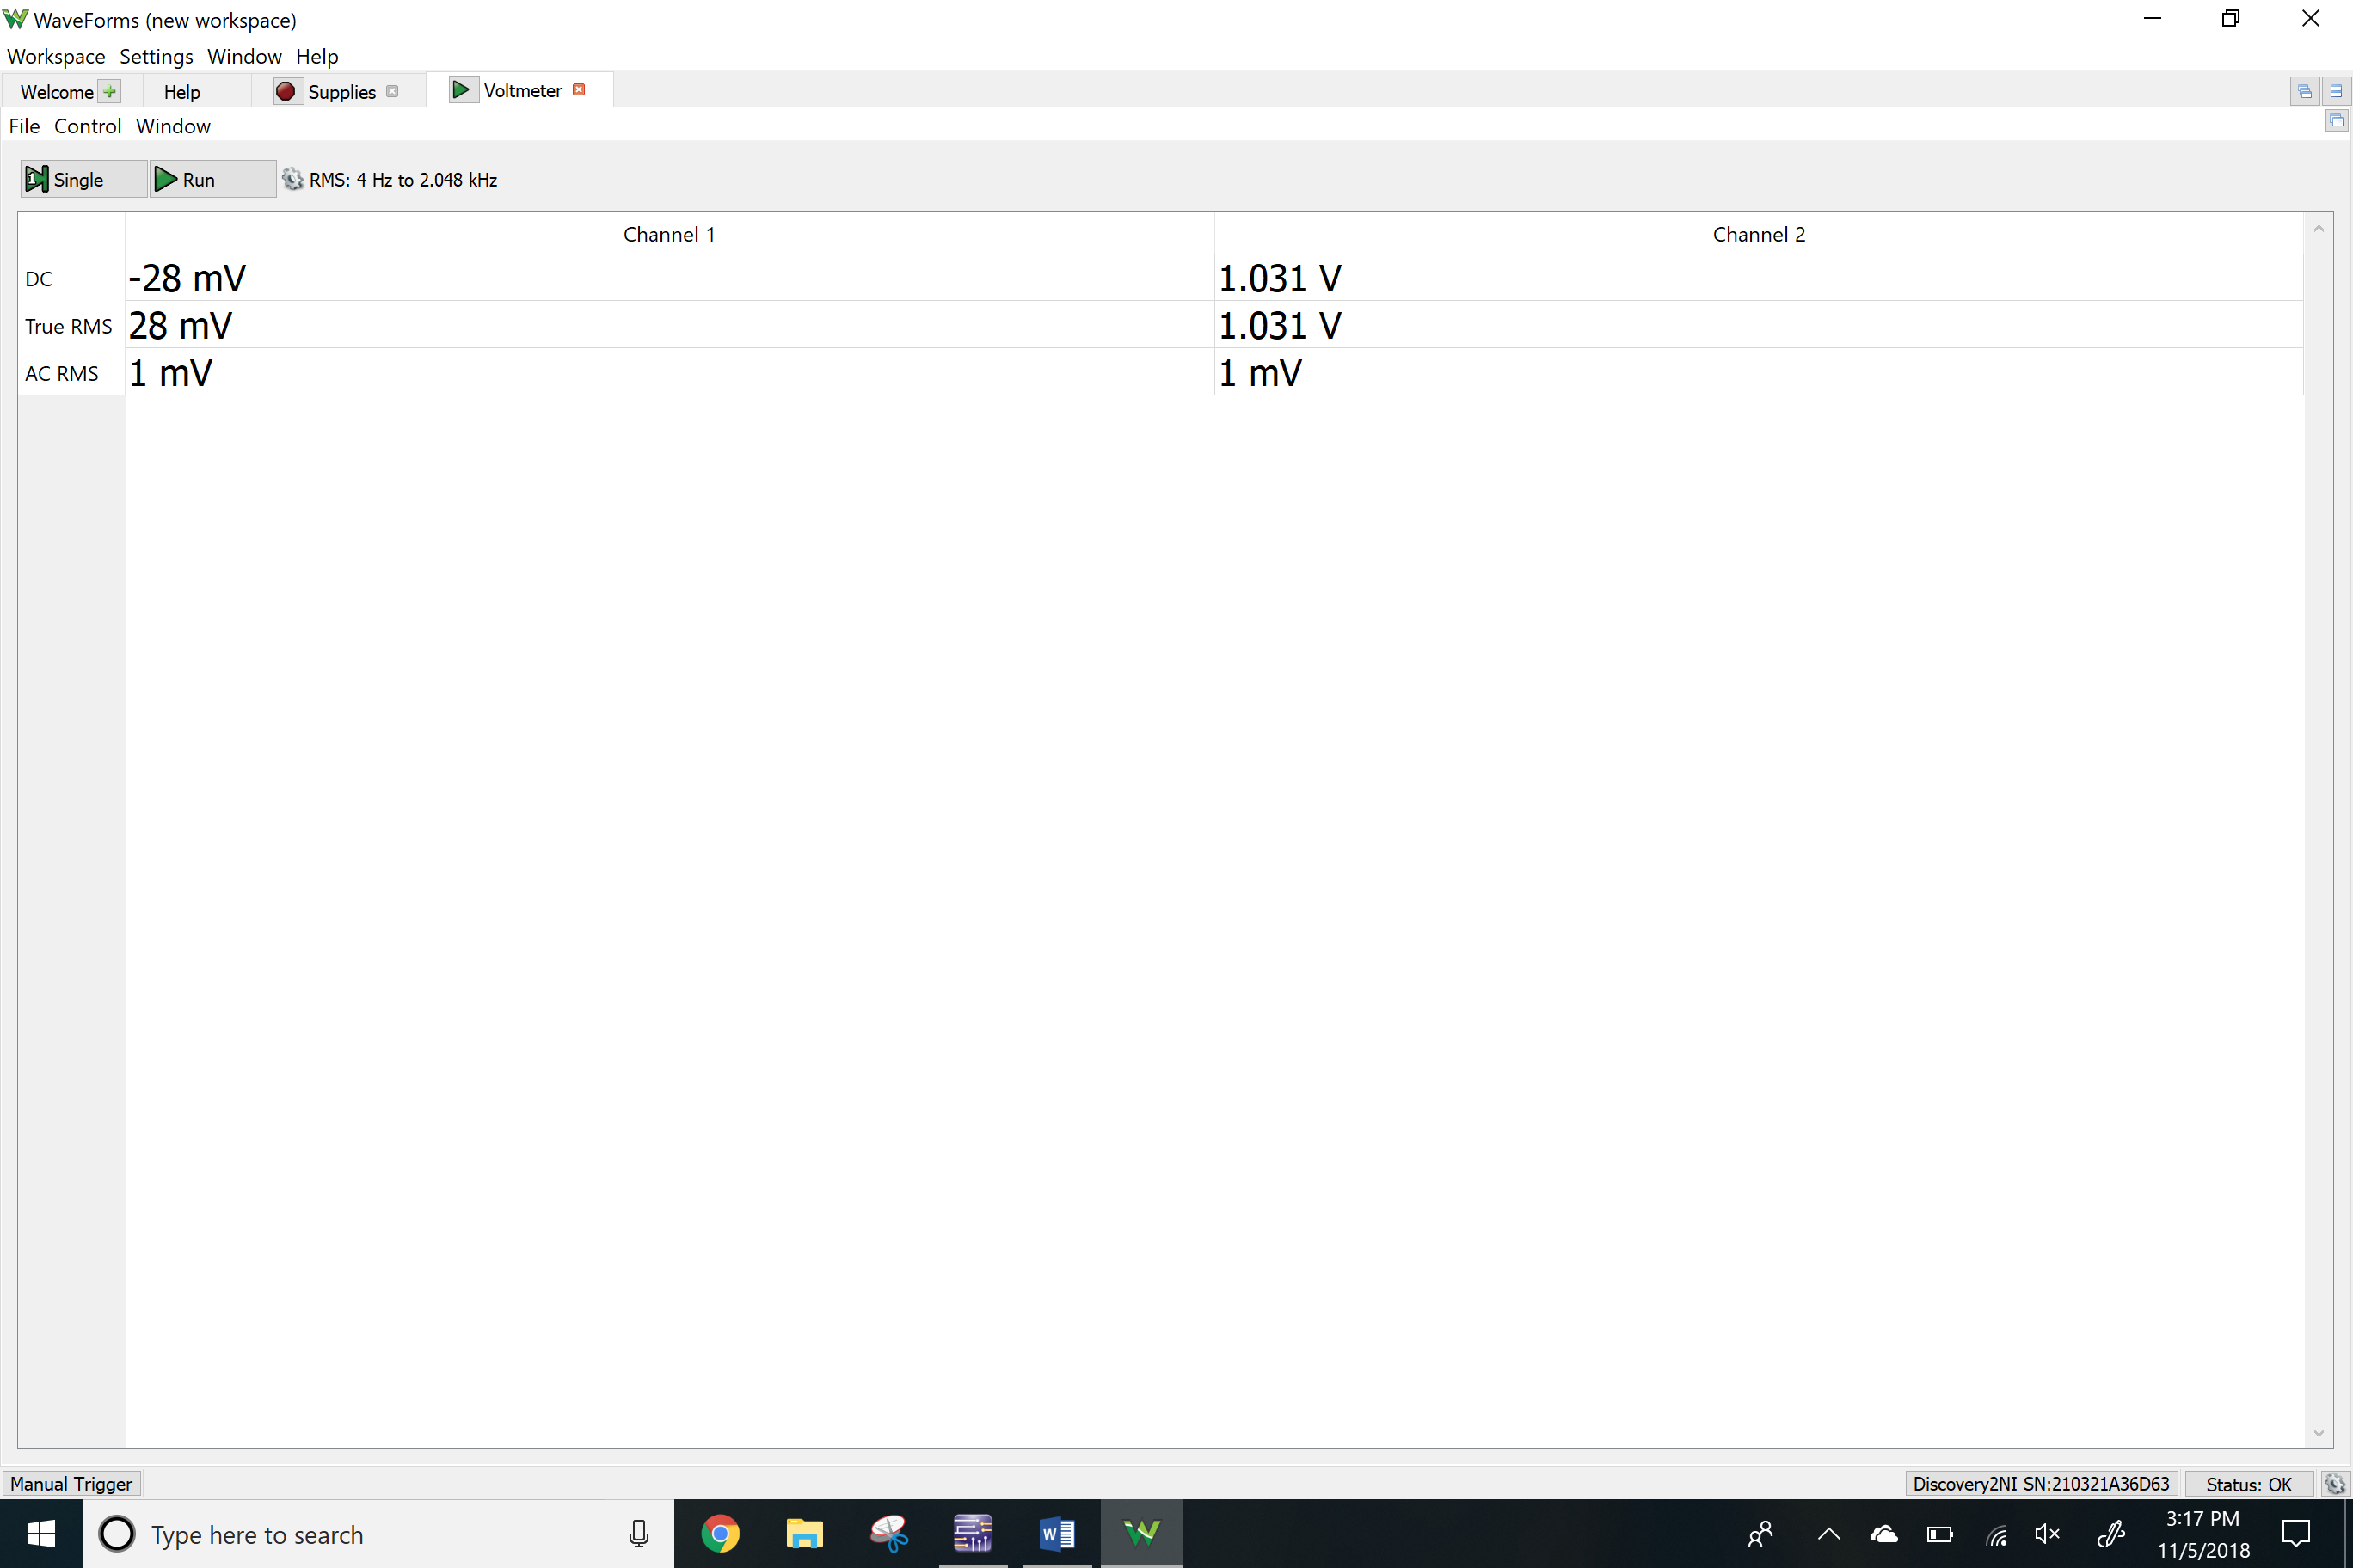

Network analyzer

Av

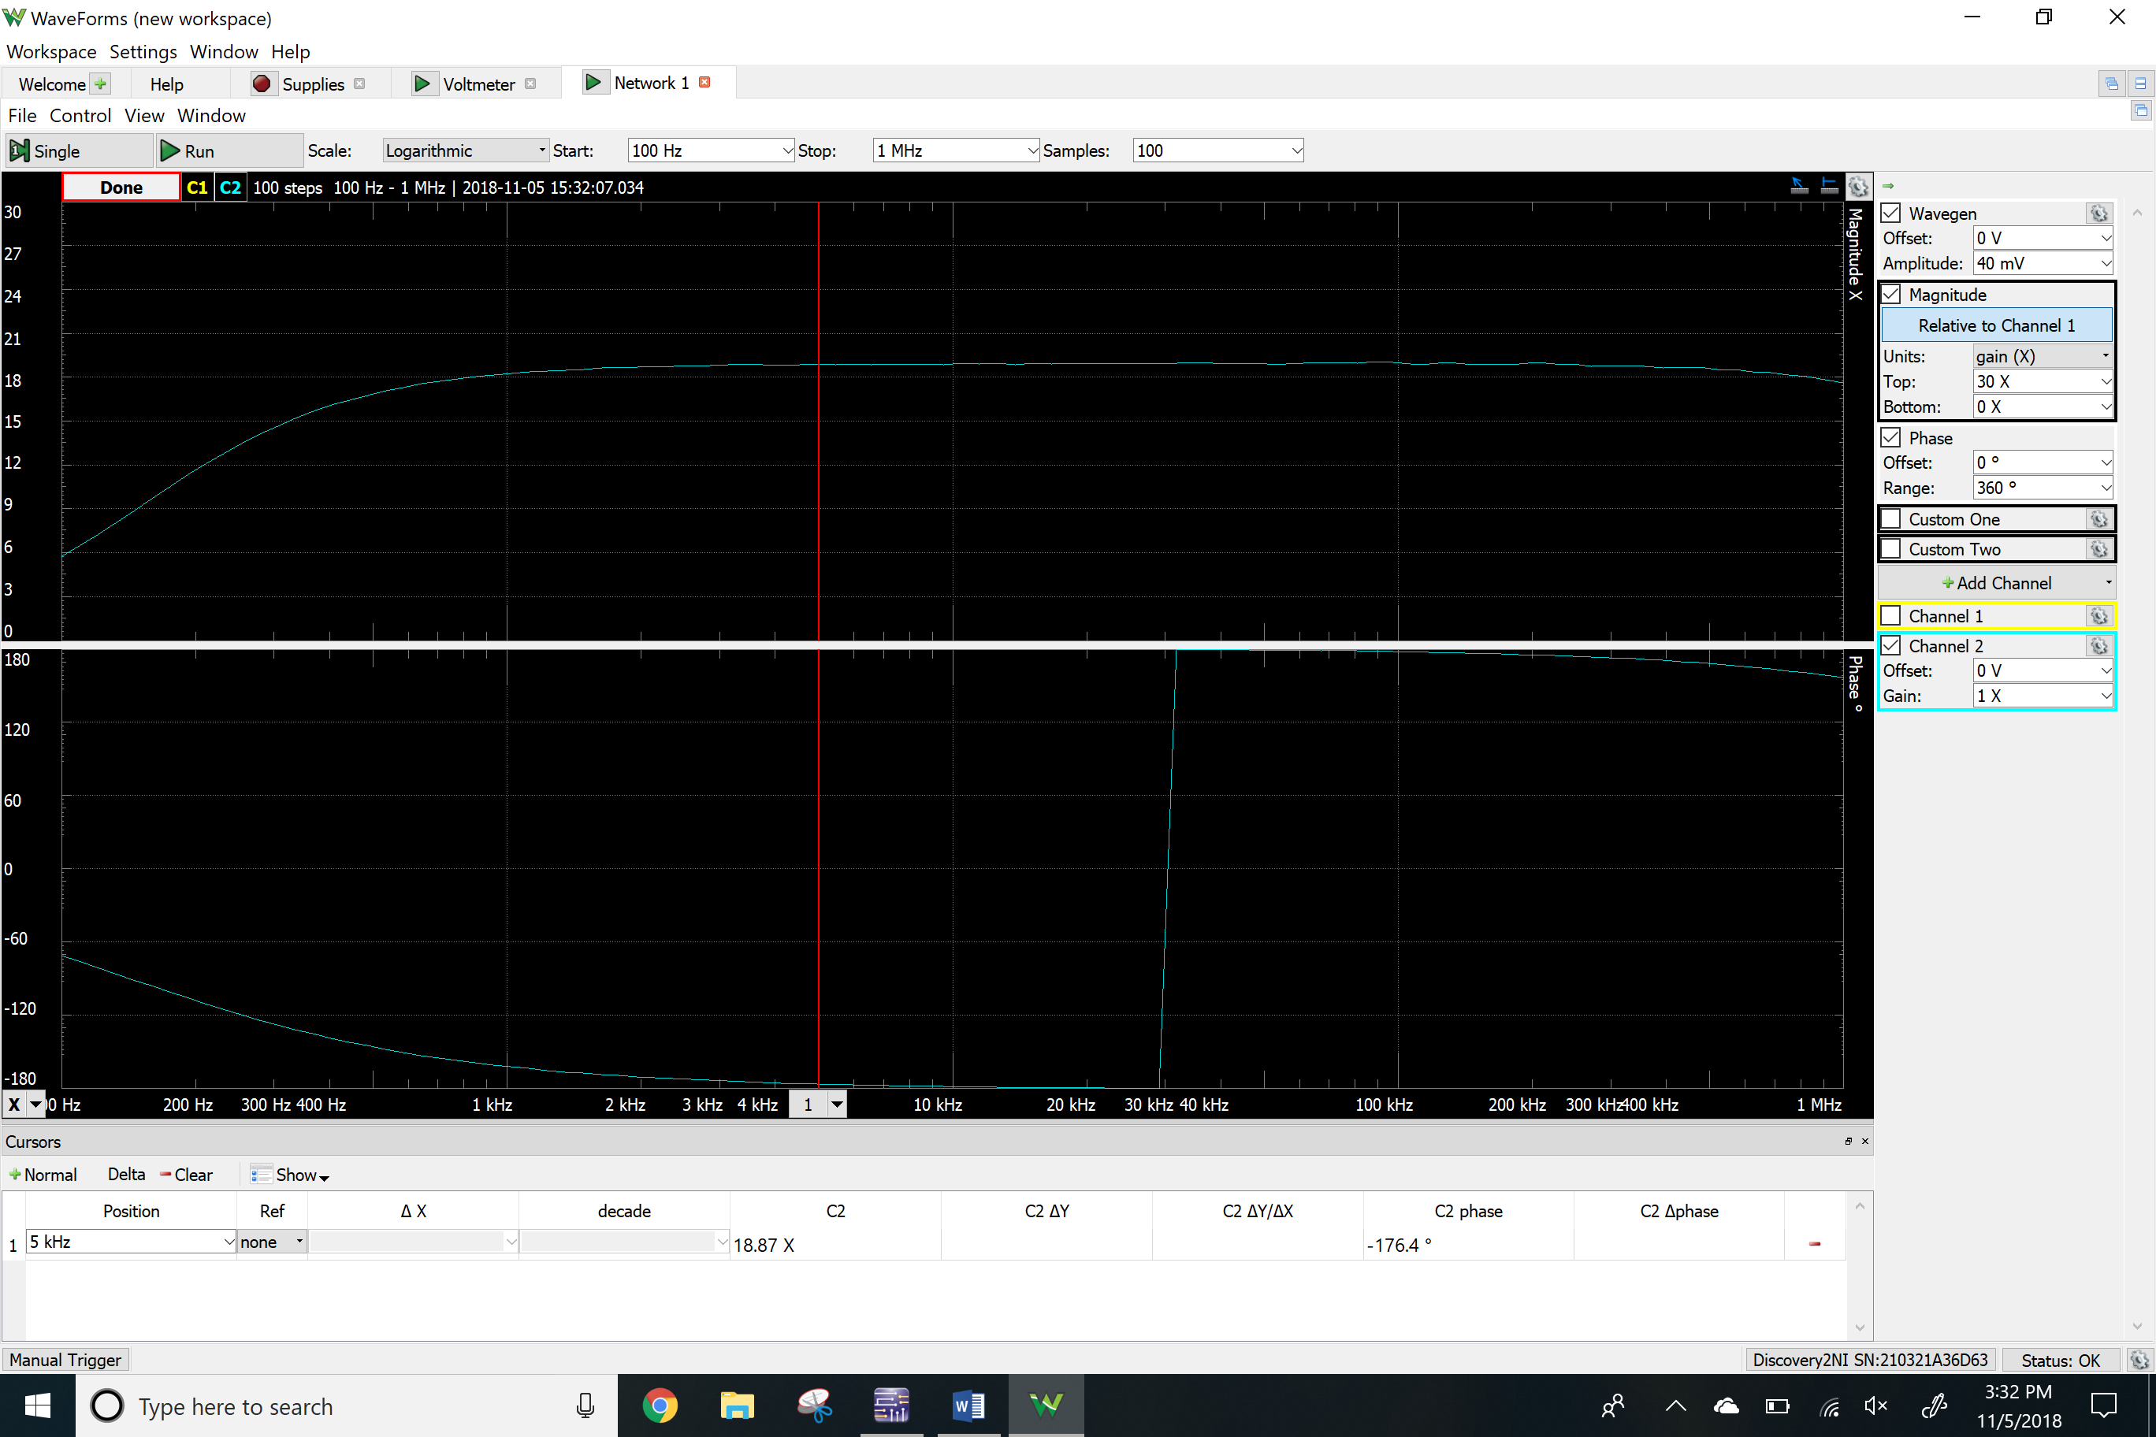

Ri

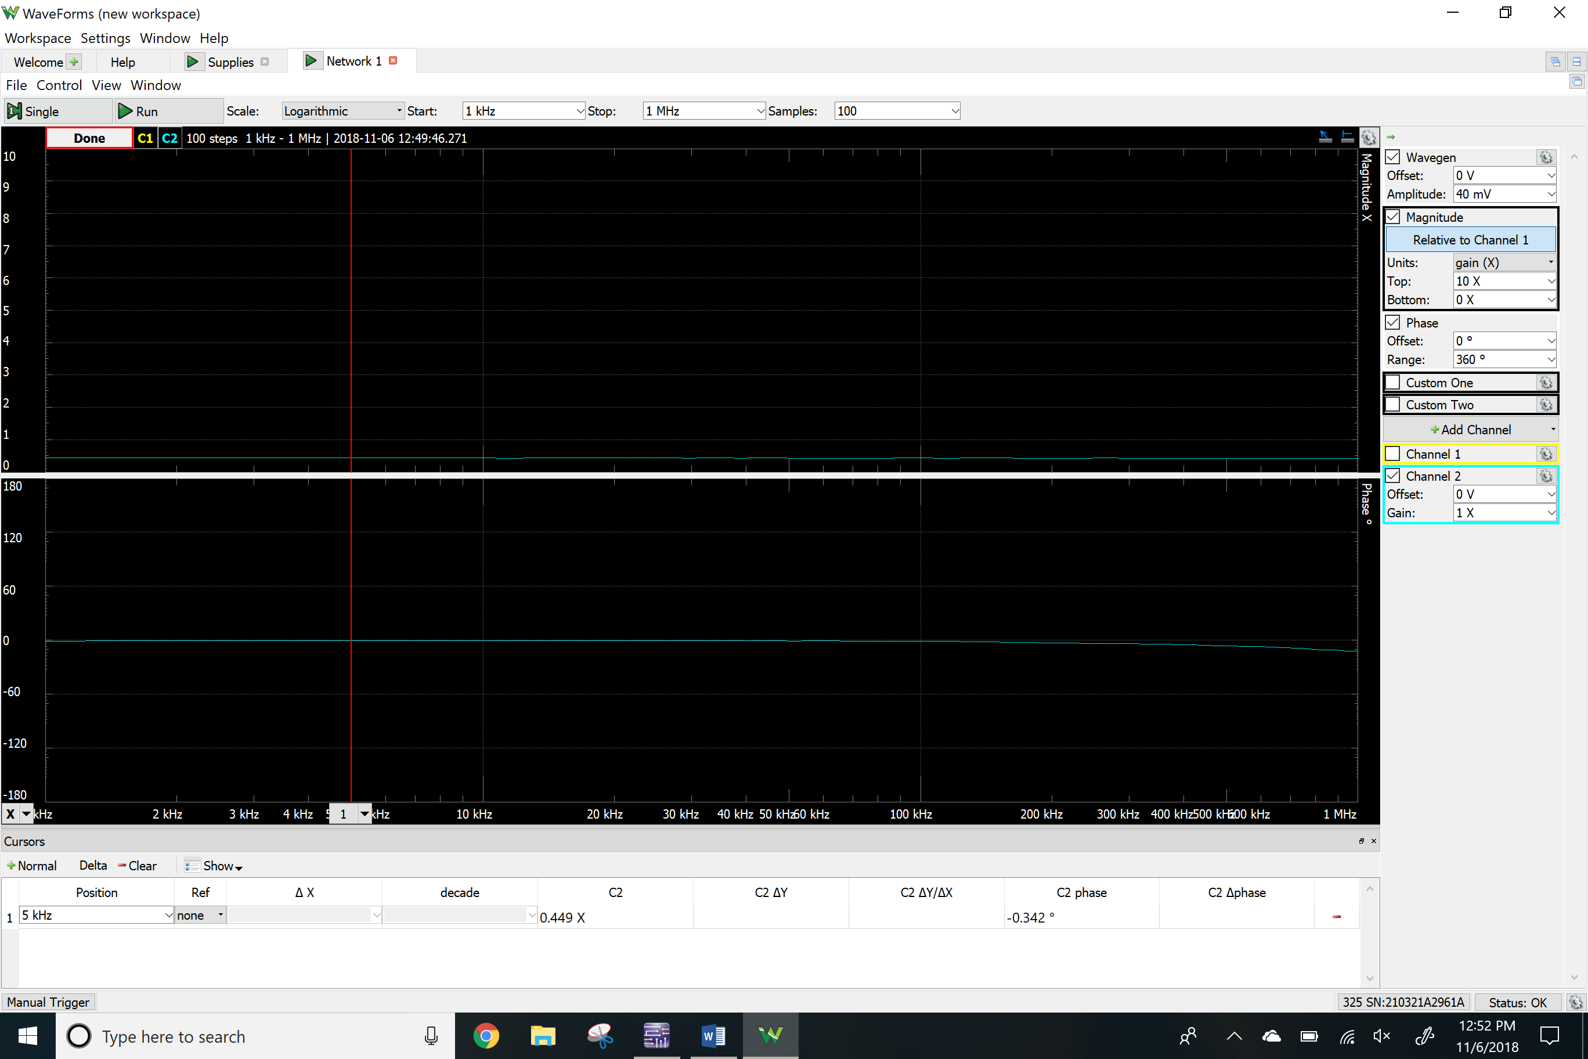

Time-domain waveform

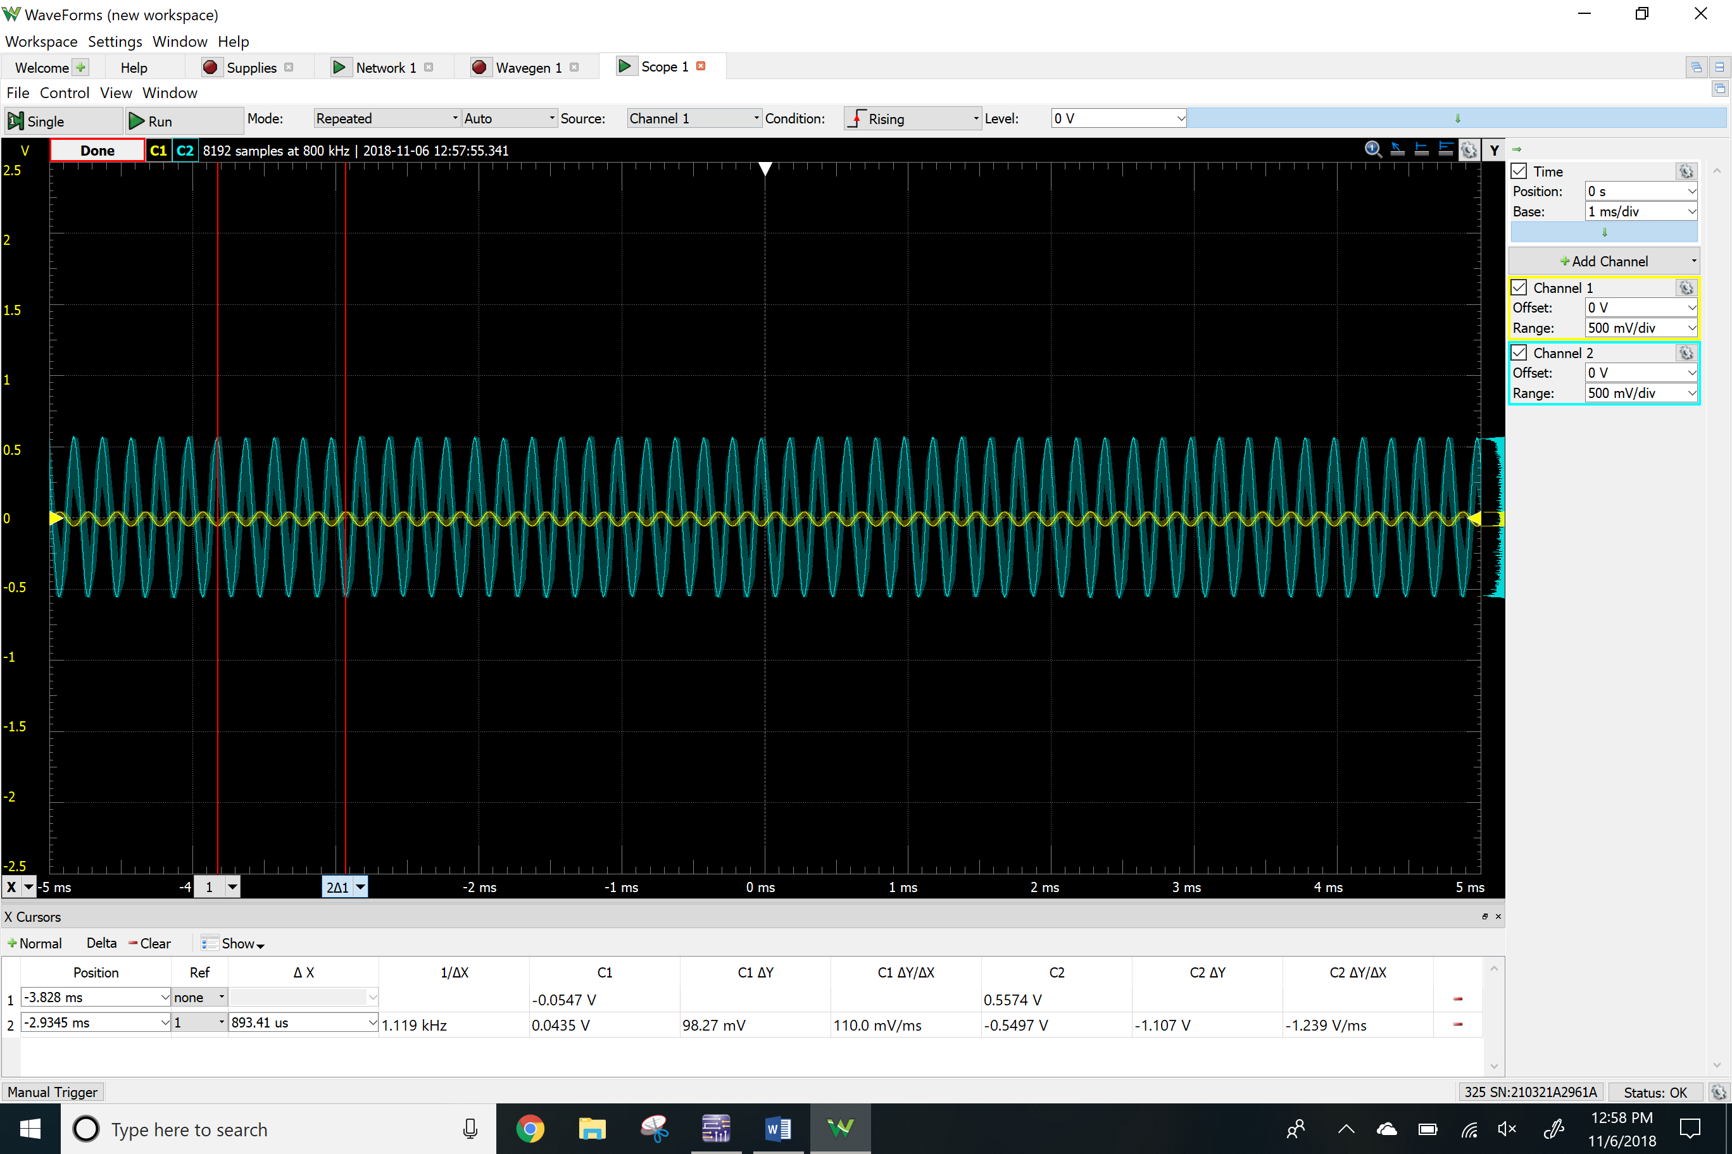

THD

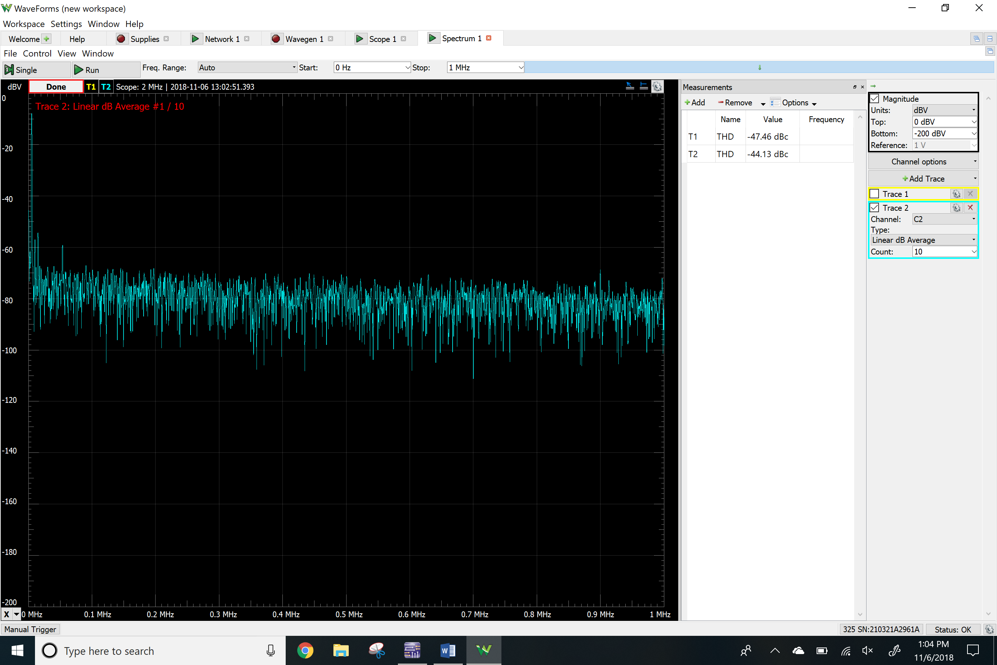

**Results**

Calculations

|  |  |
| --- | --- |
|  | BJT amplifier |
| RL | 100 Ω |
| Re | 1000 Ω |
| Rc | 2500 Ω |
| Rb2 | 1700 Ω |
| Rb1 | 3300 Ω |
| Rh | 80 Ω |
| Rg | 100 Ω |
| Vrb1 | 3.3 V |
| Vrb2 | 1.7 V |
| Vrc | 2.5 V |
| Vre | 1 V |
| Ic1 | 1 mA |
| Ic2 | 22.5 mA |

Simulations

|  |  |
| --- | --- |
|  | BJT amplifier |
| Vrb1 | 3.30 V |
| Vrb2 | 1.69 V |
| Vrc | 2.27 V |
| Vre | 1.02 V |
| Ic1 | 1.01 mA |
| Ic2 | 18.5 mA |
| Av | 19.86 |
| Ri | 1037 Ω |
| THD | 1.19 % |

Measurements

|  |  |
| --- | --- |
|  | BJT amplifier |
| Vrb1 | 3.18 V |
| Vrb2 | 1.73 V |
| Vrc | 2.60 V |
| Vre | 1.03 V |
| Ic1 | 0.867 mA |
| Ic2 | 33.6 mA |
| Av | 18.87 |
| Ri | 815 Ω |
| THD | 0.62 % |

**Conclusion**

This lab helped me understand the configurations and the basic characteristics of the BJT amplifier. I learned that we can put amplidfiers together to design two stage amplifiers. We also added a buffer in order to get the consistent gain. We have also learned by calculation that each resistor of the BJT affect the different input and output variables. All my measurements matched the simulations for the most part, but my measurement was off by little because I didn’t have the exact resistor values. In order to create this BJT circuit I had to some of the parameters to calculate the other values of the parameters.